1.Question 1

Dr Marie Stevenson makes two good recommendations about the use of PowerPoint in presentations. What are they?

b. Don’t use too many PowerPoint slides.

c. Don’t just read out your PowerPoint slides.

2.Question 2

Dr Stevenson also makes a number of points about use of voice in presentation. Which of the following comments did she make?

1. “Speak directly to your audience.”

2. “Don’t speak too loud so people are forced to listen closely.”

3. “Don’t speak too fast.”

4. “Take pauses.”

c. 3, 4

3.Question 3

Dr Alyssa O’Brien suggests that there are two challenges facing students doing presentations in academic contexts. What are they?

a. Determine the format and expectations of presentations in your academic field.

b. Find your own argument and present it with authority.

1.Question 1

Consider the following presentation assessment from a Linguistics unit entitled ‘Language and Power.’

*Students will need to individually present each week on the readings for that week. Each student will be allocated a week in which to present. The presentations will last for 15 minutes, with the final 5 minutes allocated to discussion of the topic amongst the tutorial group. Student will be required to quickly present the main points of the readings, find similarities and differences, and try to apply the ideas to real world language situations. They will also need to lead the discussion in the final 5 minutes of the presentation.*

What is the main purpose of this presentation?

c. To display subject knowledge and critical thinking skills

2.Question 2

Consider the following presentation assessment from a Linguistics unit entitled ‘Language and Power.’

*Students will need to individually present each week on the readings for that week. Each student will be allocated a week in which to present. The presentations will last for 15 minutes, with the final 5 minutes allocated to discussion of the topic amongst the tutorial group. Student will be required to quickly present the main points of the readings, find similarities and differences, and try to apply the ideas to real world language situations. They will also need to lead the discussion in the final 5 minutes of the presentation.*

You are going to make this presentation next week, and would like to show a video of a short segment of classroom discussion. What are your three most important considerations with regard to Place before you make your presentation?

b. Whether the projector is working.

c. Whether the sound is working.

e. Whether you can play the video file of the classroom discussion on the computer in the room.

3.Question 3

Which of the following are possible ways to organise the body of your presentation, according to lesson 5.2b?

a. Chronological order

d. Residues approach/comparing points of view

e. General to Specific

1.Question 1

Consider the following slide from a presentation on crop rotation in the 18th century.

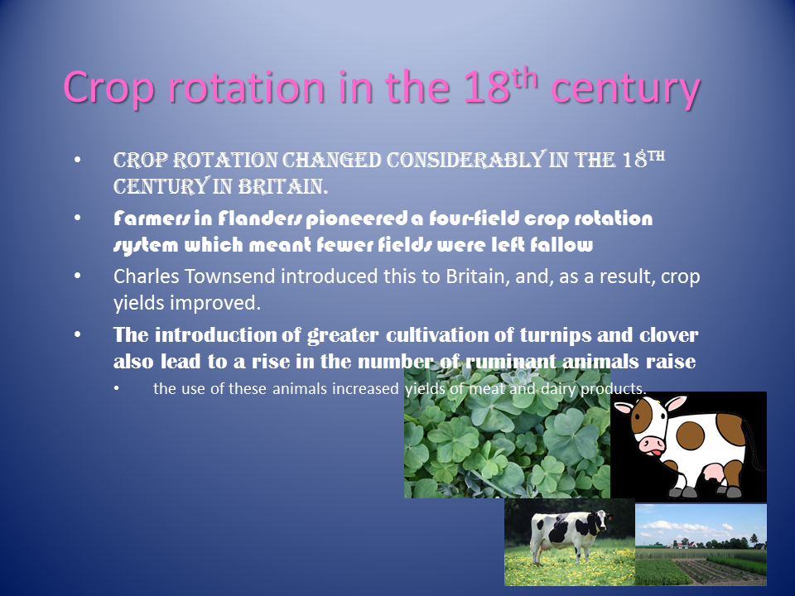

What problems does it have in terms of readability of text?

c. The body text is too small.

d. There are too many fonts being used on the slide.

e. There is too much text on the slide.

2.Question 2

Consider the following slide from a presentation on crop rotation in the 18th century.



What problems does it have in terms of use of images?

a. The images are too small.

d. There is not enough space around the images.

3.Question 3

What is signposting language?

d. Words and phrases designed to explicitly signal the structure of a presentation to an audience.

1.Question 1

What tips does lesson 5.4a give for engaging your audience?

d. Make eye contact with your audience.

e. Don’t turn your back on the audience.

f. Model the engagement you want from your audience.

2.Question 2

Which of the following are techniques suggested in lesson 5.4b for engaging your audience at the beginning of your presentation?

b. Have a short quiz.

c. Put up a discussion question.

3.Question 3

It’s the end of the presentation, and someone had asked you a difficult question. What do you do?

a. Ask them to repeat the question to buy more time.

c. Throw the question back to the audience to answer.